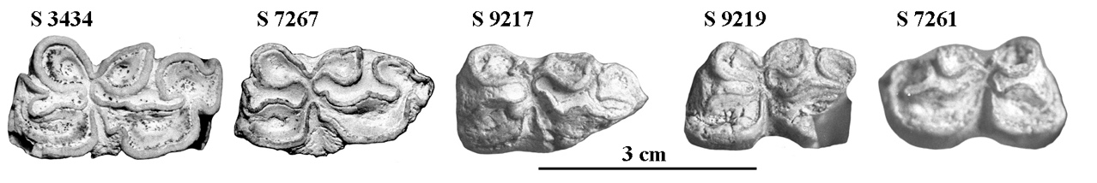

Figure S16. Occlusal views of lower cheek teeth of *E.* cf.  *wuesti*. All the accession numbers should be prefixed by IQW.